QUESTION 2

**TOP**

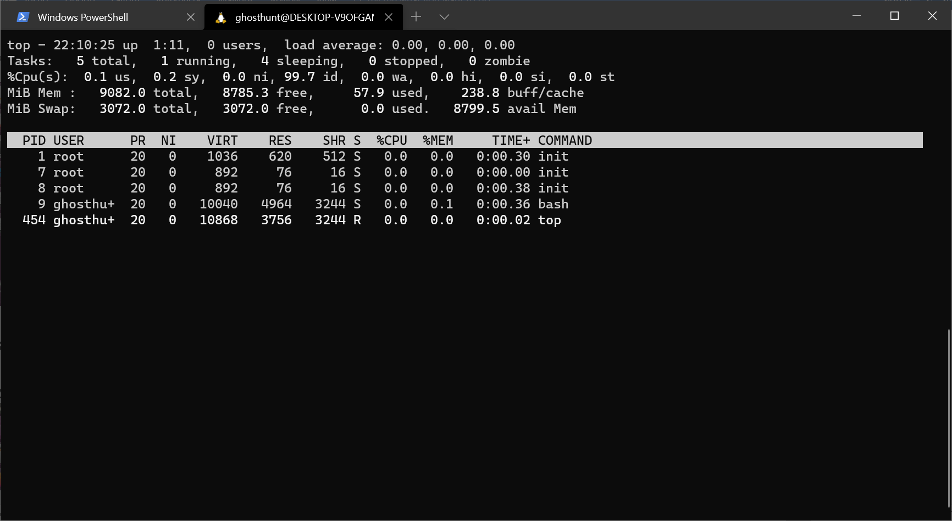

tasks, memory,cpu,swap are displayed.

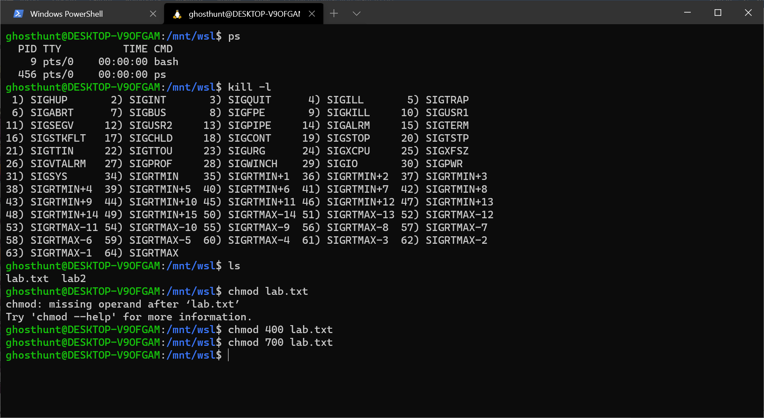

**ps**

ps shows all the active processes

**kill -l**

**chmod**

by using chmod 400 <filename> makes the file permission read only

by using chmod 700 <filename> makes the file permission read and write

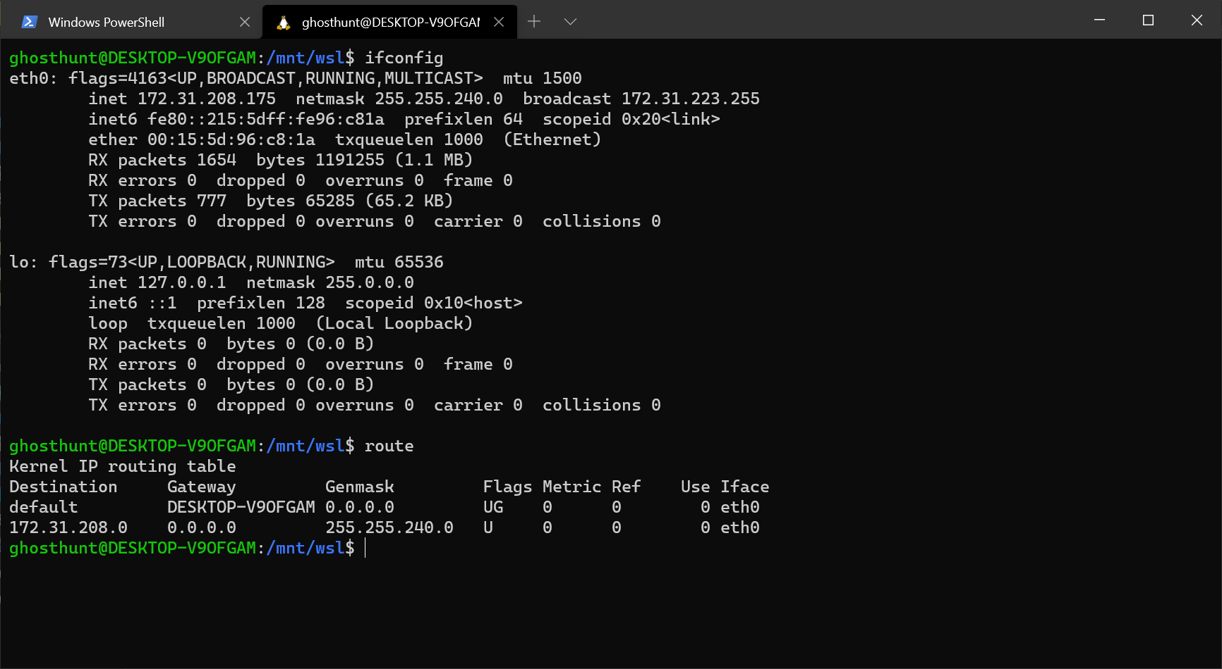

**ifconfig**

**route**

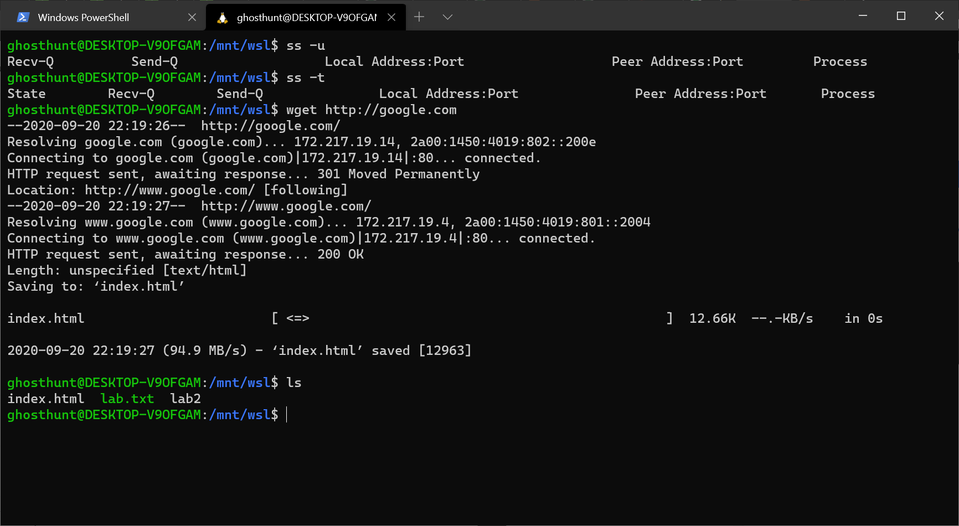

**ss**

**ss-u**

**ss-t**

**wget**

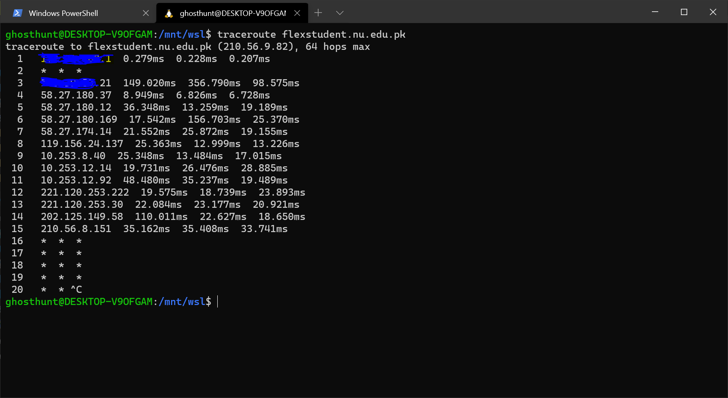

**Traceroute**

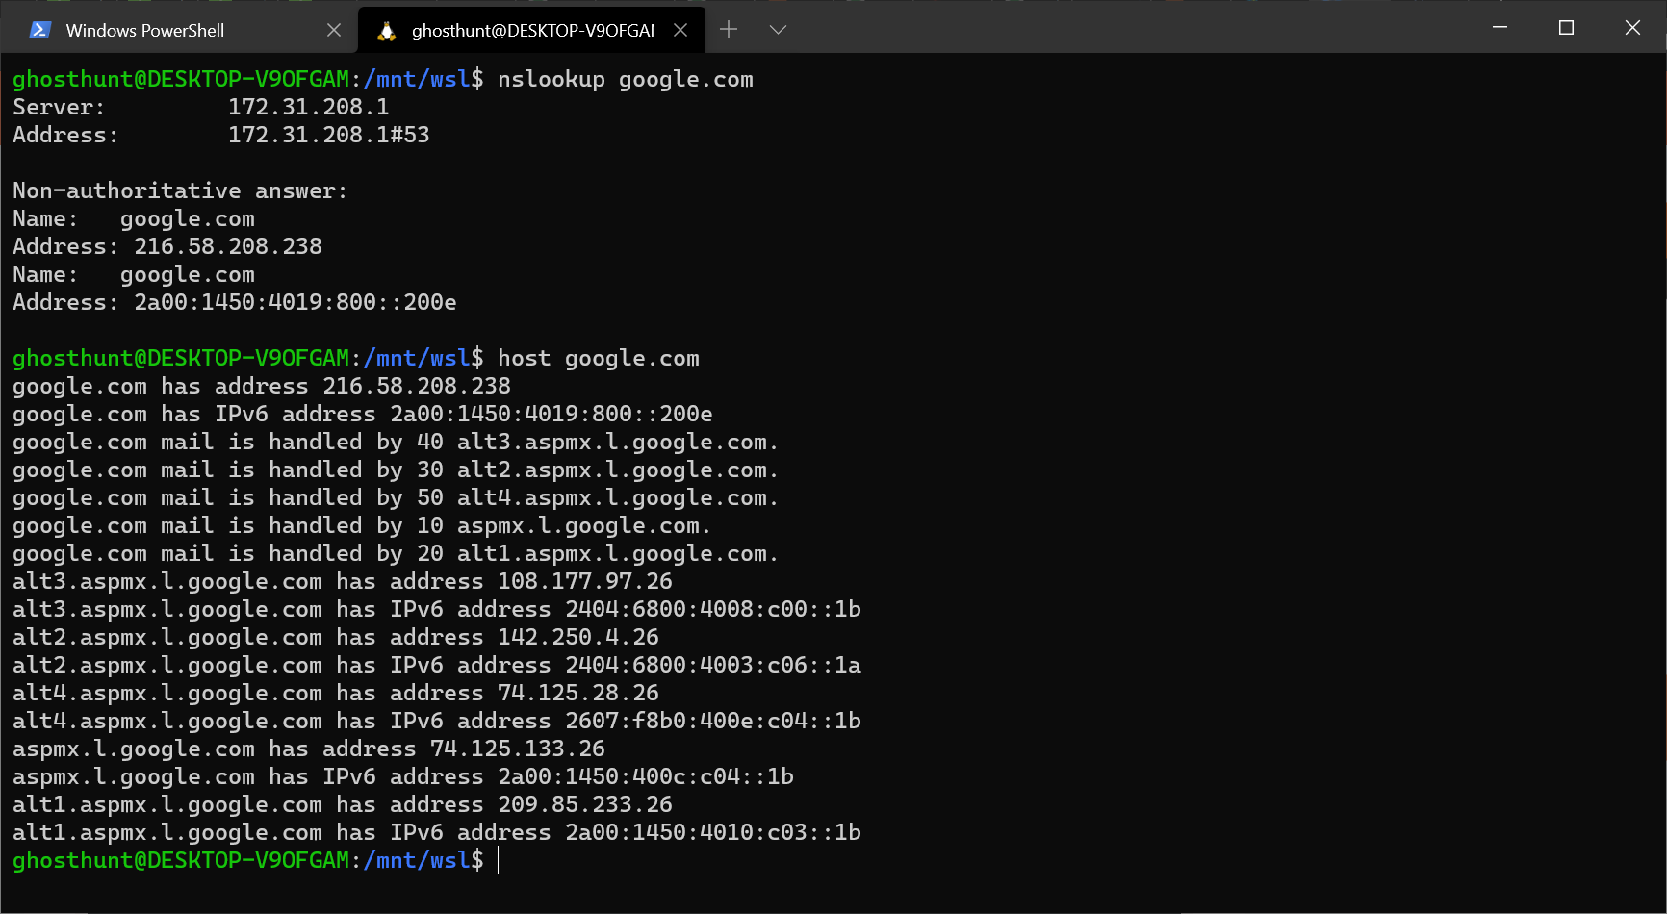

**nslookup**

**host**